
Cloud Computing Lab

Submitted to:
Engr. Muhammad Shoaib

Submitted by:
Hania Akbar

Reg no:
2023-BSE-026

Section:
A

Lab 7 – Environment Variables, PATH, UFW, and SSH Key Authentication

Task 1 — Print & filter environment variables
- Print all environment variables:
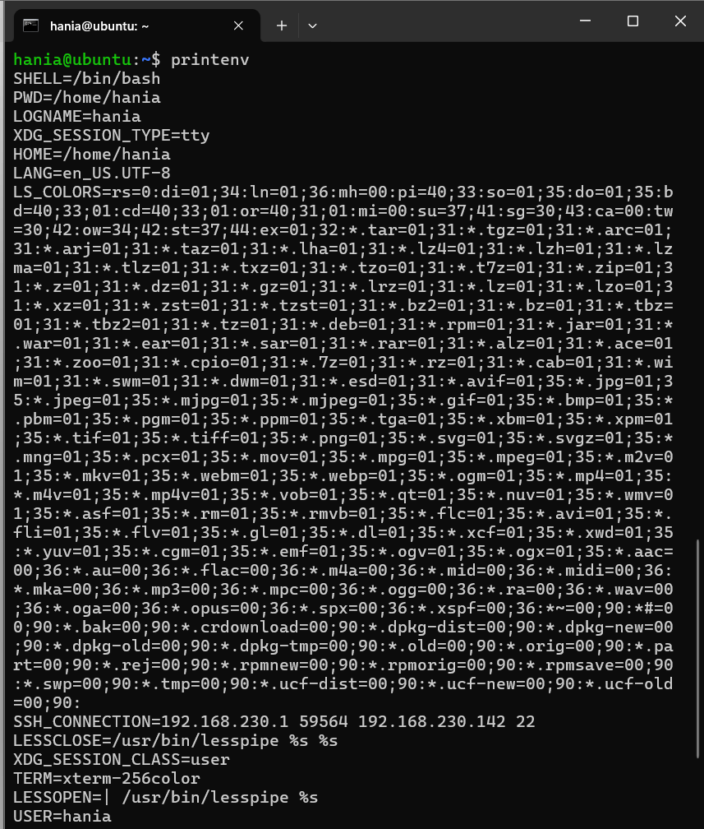
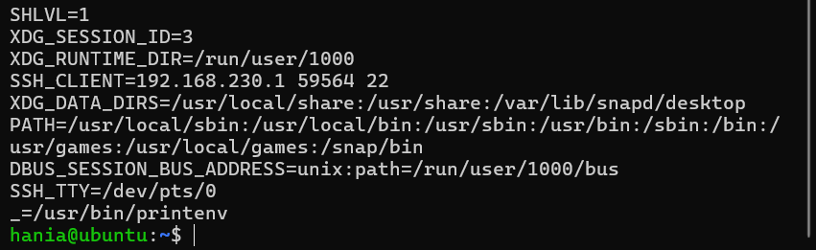

- Filter for SHELL, HOME and USER — run these greps together and capture one combined screenshot:
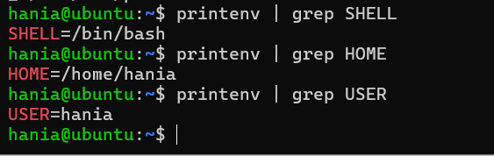

Task 2 — Export DB_* variables temporarily and observe scope
- Define all DB_* variables (run the three exports one after another). Capture them in one screenshot showing the three export commands and their execution:
- Echo the three variables (run the three echo commands together) and capture one screenshot showing their outputs:

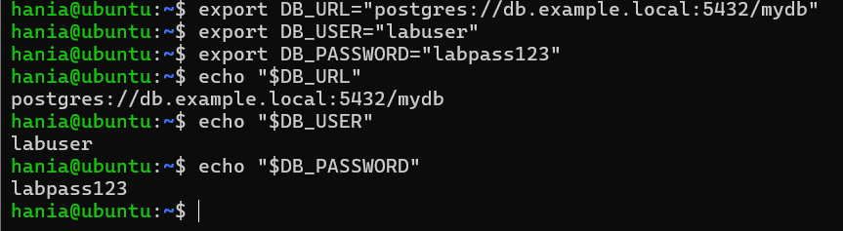
- Show all DB_ variables with a single grep command (capture that output):
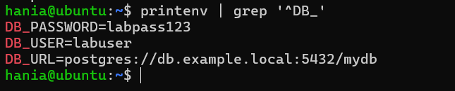
- Close the bash session (e.g., exit) and reopen a new terminal. Verify the variables are gone by running the echo(s) and the grep together; capture both checks in one screenshot:
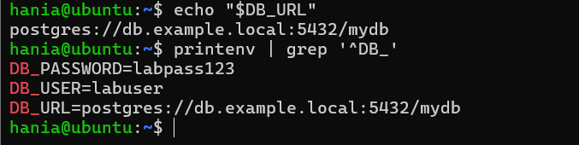

Task 3 — Make DB_* variables persistent in ~/.bashrc
- Open ~/.bashrc in an editor and append the three export lines. Capture the editor showing the three lines added (single screenshot):
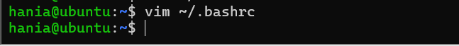
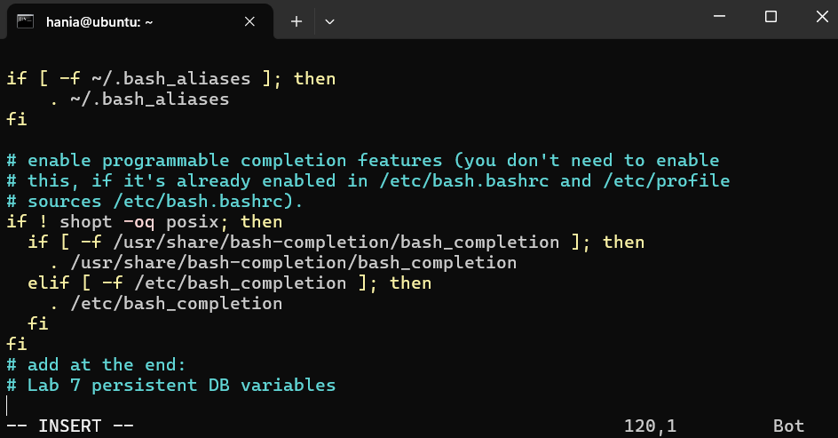

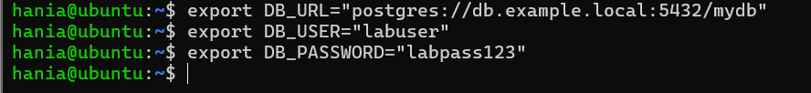

- Source ~/.bashrc and capture the source command in one screenshot together with the next verification commands (grouped): run source ~/.bashrc and then immediately run the three echoes and a single grep, capturing all of these in one screenshot:
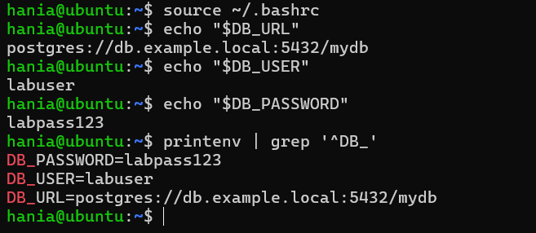

- Close and reopen terminal. Verify persistence by running one echo and the grep together — capture both in one screenshot:
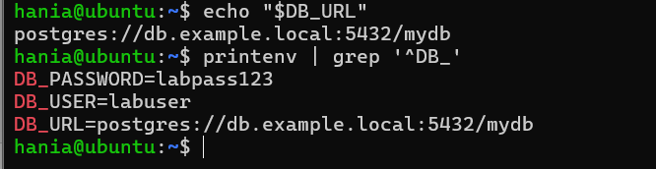

Task 4 — System-wide environment variable, welcome script, and PATH
- View /etc/environment:
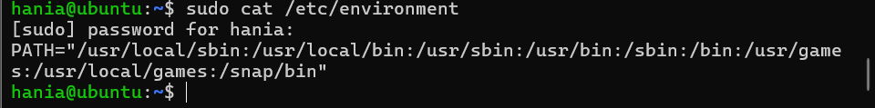
- Show current PATH:
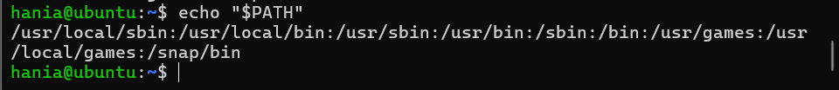

- Edit /etc/environment and add Class:
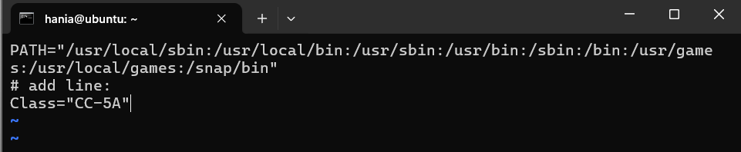
- Re-login or open a new shell and show Class and PATH together (grouped prints): run echo $Class and echo $PATH together and capture in a single screenshot:
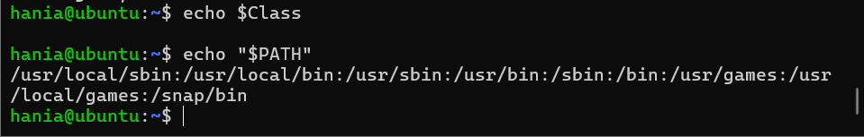

- Create welcome script at your home directory (~/welcome) and make it executable (capture the heredoc creation and chmod together in one screenshot if possible):
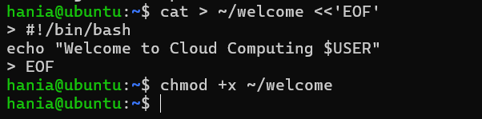
- Run the script from your home directory using ./welcome:
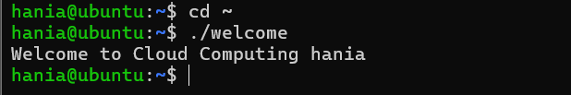

- Add your home directory to PATH in ~/.bashrc. NOTE: per your instruction we do not include an export PATH line here — only add the PATH modification line in the file. Capture the editor showing that PATH line in one screenshot:
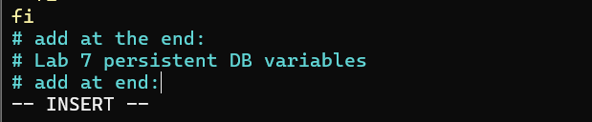
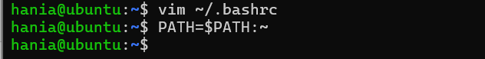

- Apply the change and run welcome — capture these runtime commands in a separate screenshot (must be taken separately from the editor screenshot):
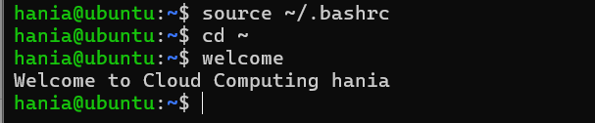

Task 5 — Block and allow SSH using ufw (firewall)
- Enable ufw and show status (group both commands in one screenshot if you run them together):
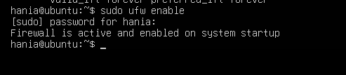

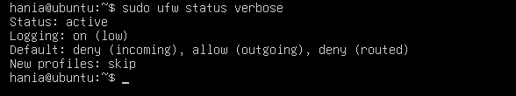

- Deny TCP port 22 and show status (run deny and status numbered together and capture in one screenshot). Use short form as requested:
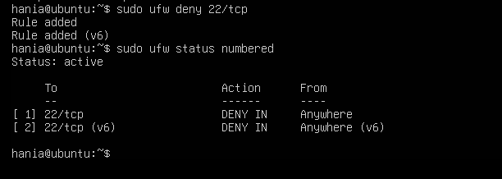
- From Windows host attempt to SSH (expected to fail) — capture the host-side SSH attempt in one screenshot:
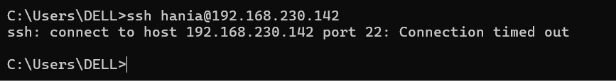

- Allow SSH back and reload, then show status (group allow, reload, status in one screenshot if run together). Use short form as requested:
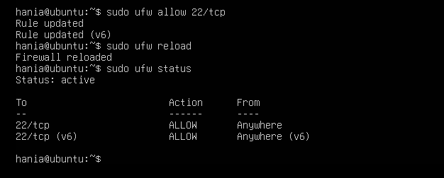

- From Windows host attempt SSH again (should succeed) — capture successful login in one screenshot:
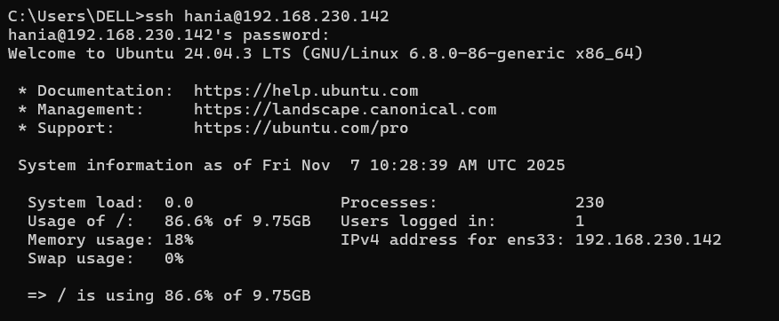

Task 6 — Configure SSH key-based login from Windows host
- Generate ed25519 key pair (if needed) and show the generated files in one screenshot (run ssh-keygen and then list ~/.ssh):
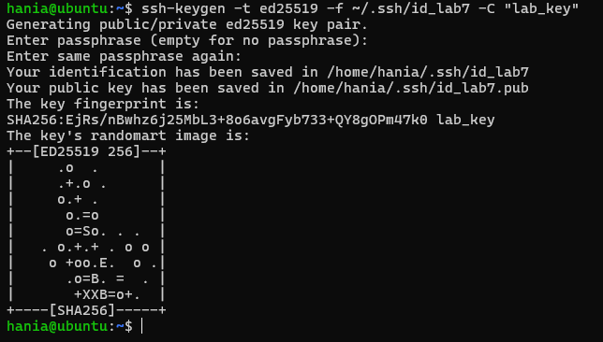
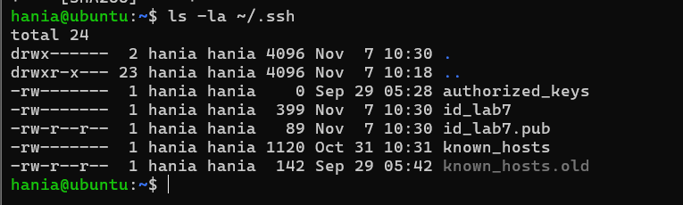

- Show the public key content (single screenshot):
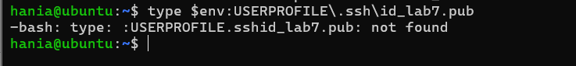
- Clear the known_hosts file content and verify it is empty (single screenshot):
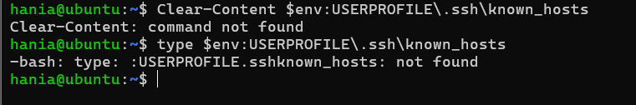
- Connect to the Ubuntu server using the standard SSH command (this will prompt to accept the server host key because known_hosts is empty). Capture the connection prompt/accept step in one screenshot:
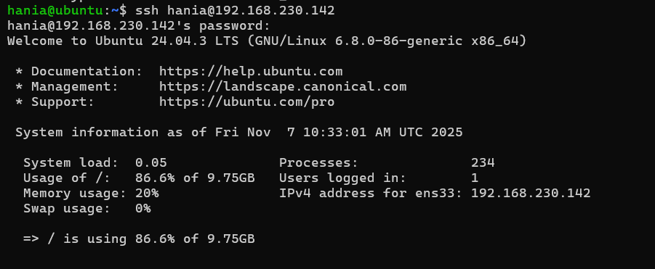

- After the successful connection, view the known_hosts file to show the server host key was added (single screenshot):
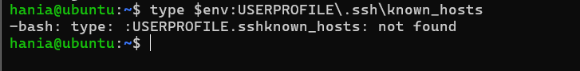

B. On Ubuntu server — group related server-side commands:
- Prepare the ~/.ssh directory and clear authorized_keys (this will create the directory if missing, set the correct directory permissions, and truncate the authorized_keys file). Capture this command sequence and its output in one screenshot:
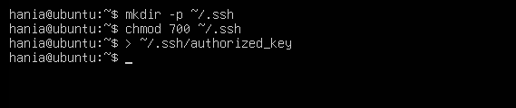

- Append the public key, set file permissions, and show the resulting authorized_keys (capture commands and resulting file content in one screenshot):
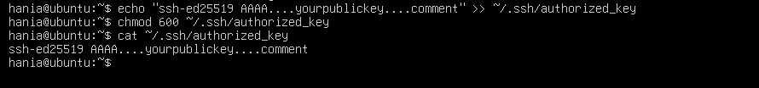
- From Windows host test passwordless login (capture successful login in one screenshot):
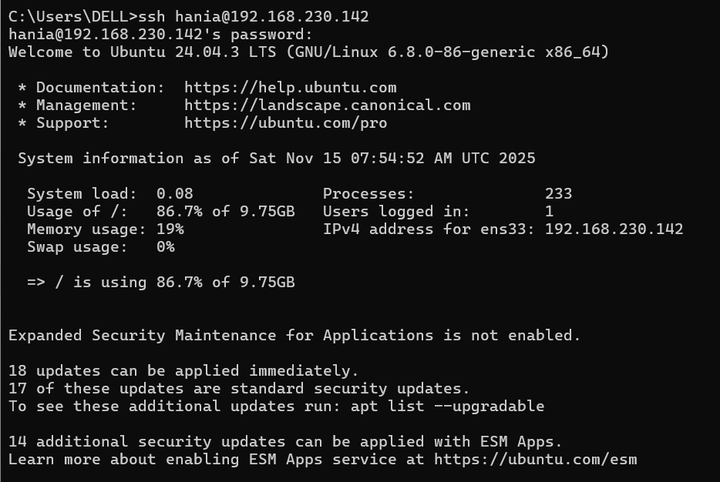

- Also demonstrate explicit identity usage (single screenshot):
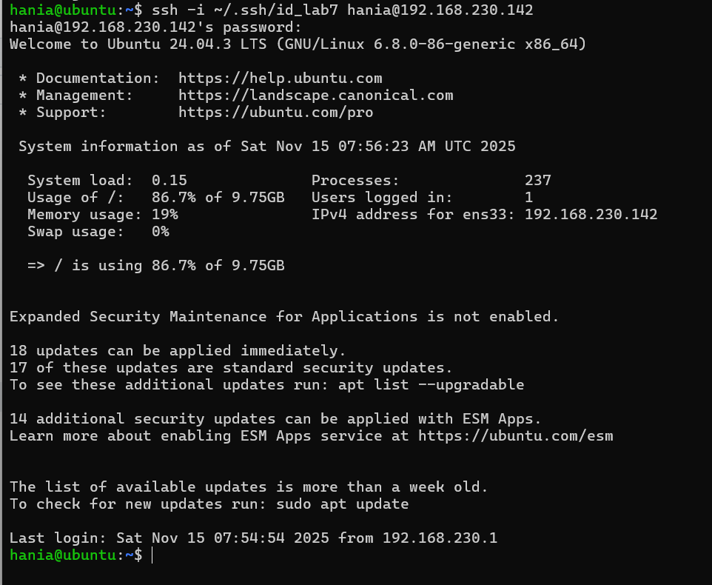

Exam Evaluation Questions

Q1: Quick Environment Audit
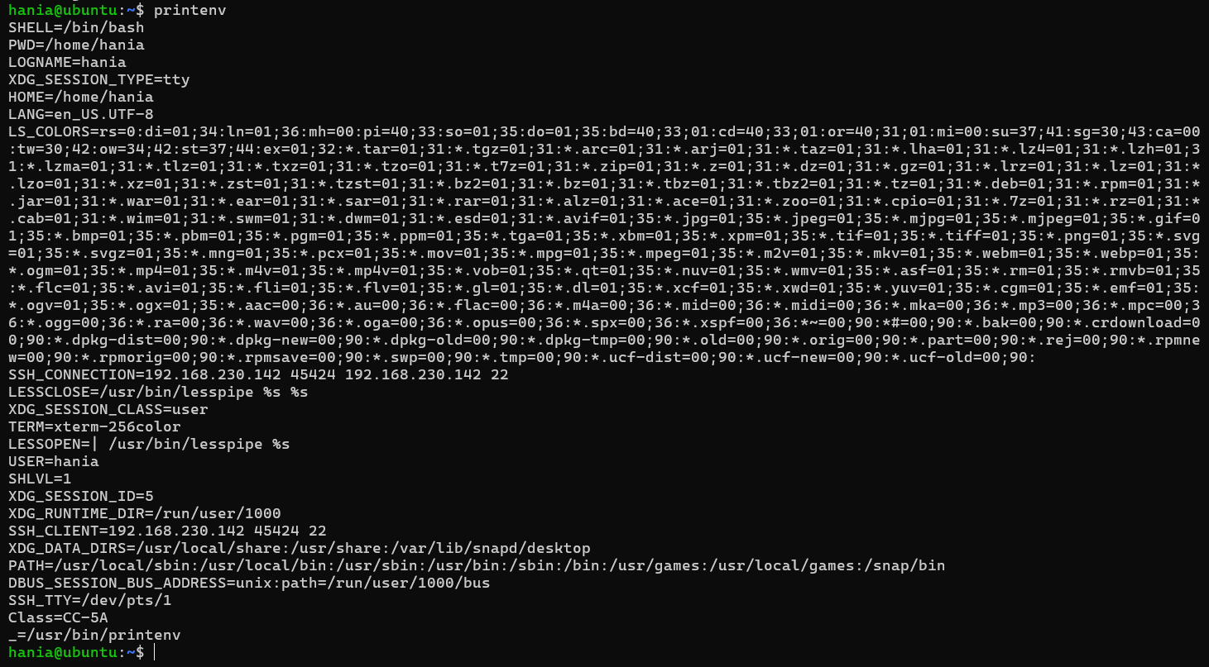

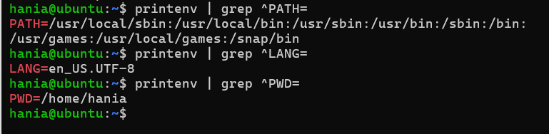

Q2: Short-lived Student Info

1. Set 3 environment variables

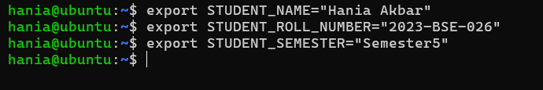
2. Print the values
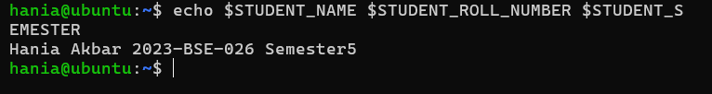

- Show STUDENT_ variables with printenv | grep*
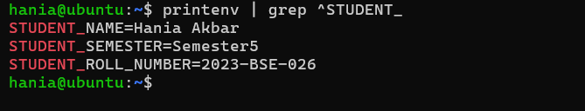

- Open a new terminal and show variables are gone
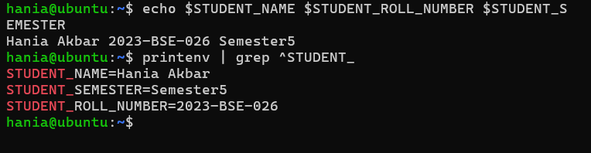

Q3: Make It Sticky (Persistent Student Variables)
- Edit ~/.bashrc
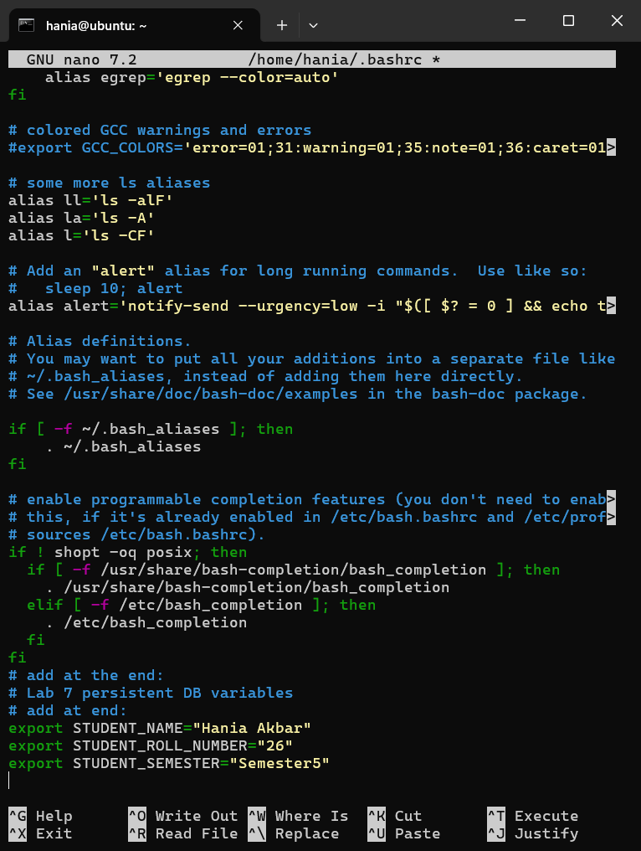

2. Reload the shell config
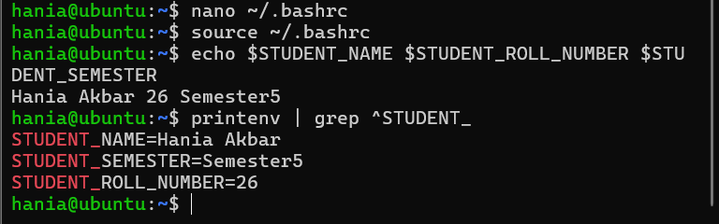

3. Close terminal → open new one → verify persistence
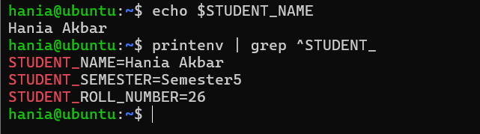

Q4: Firewall Rules — Block & Restore ICMP Ping
- Enable UFW and show status
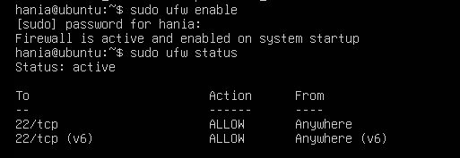

- Deny ping (ICMP) + show numbered rules
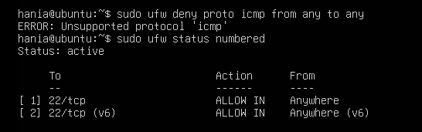

- From Windows host (or other client), ping the server
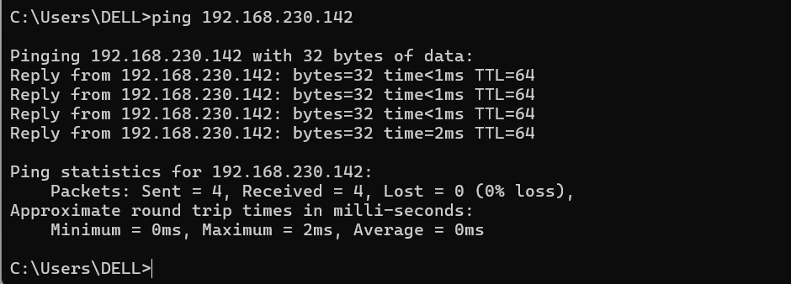

- Re-allow ping (ICMP) (or remove the deny rule) and capture the allow/reload/status sequence in one screenshot

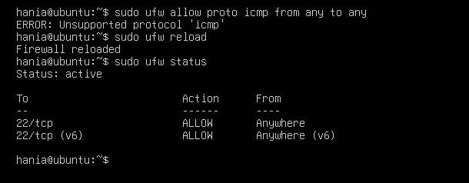

- From the client, ping the server again and capture successful replies in one screenshot.
